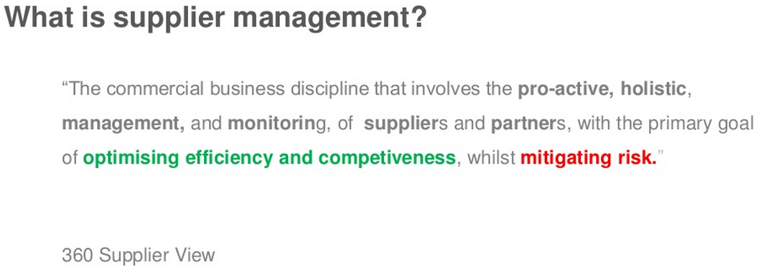

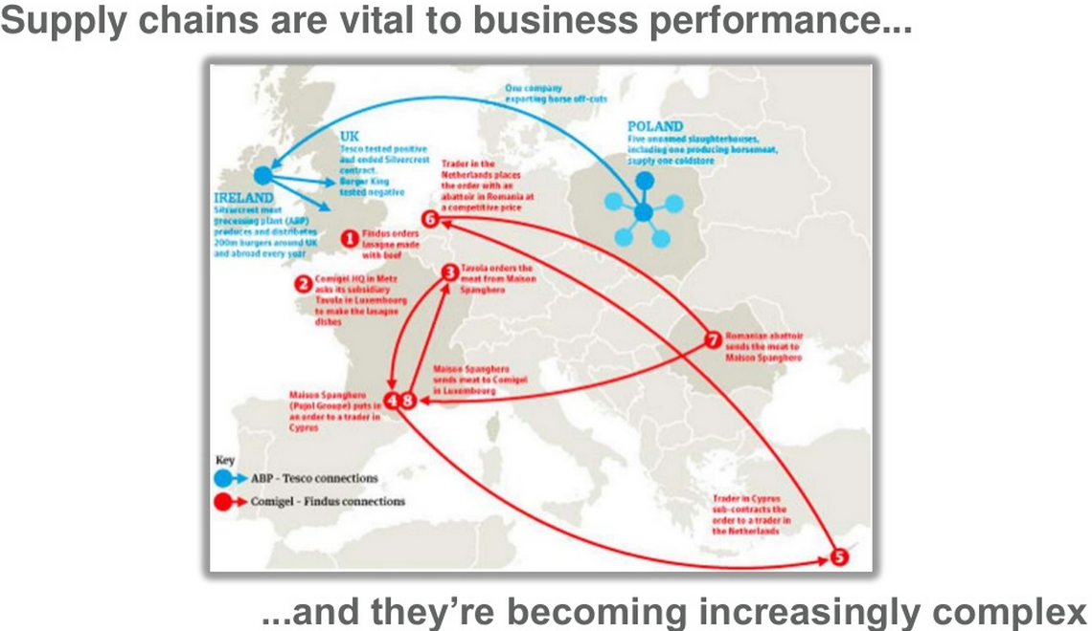

**Three pillars in Supplier Management:**

1. Supplier Risk Management
2. Supplier relationship management
3. Supplier performance management

**A: Supplier Risk Management:**

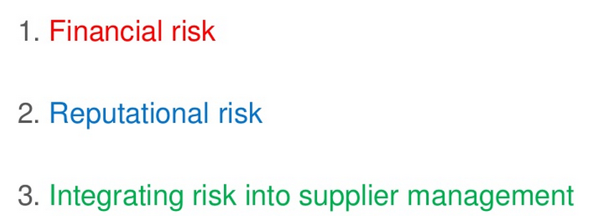

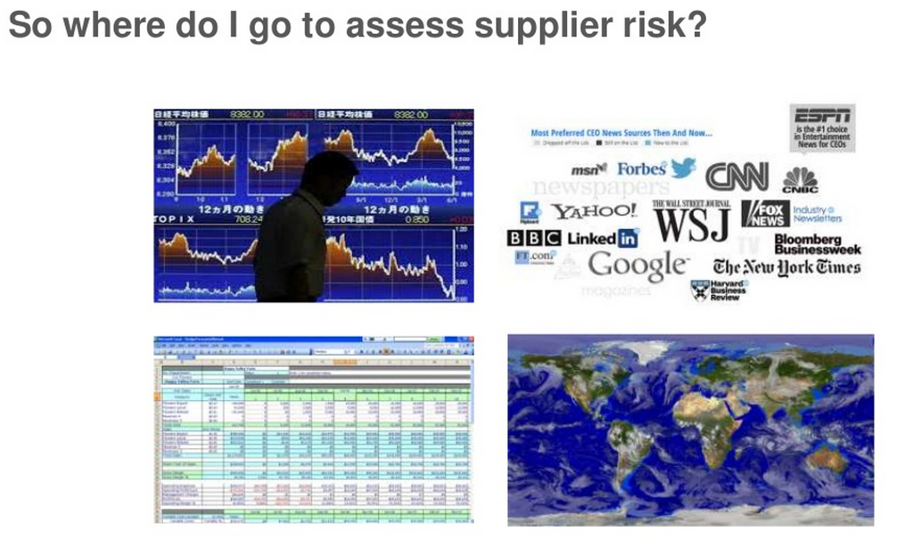

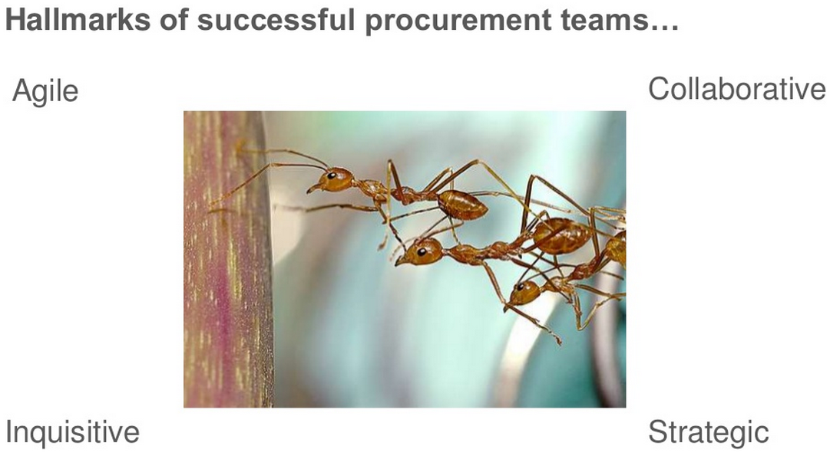

**B: Supplier Relationship Management**

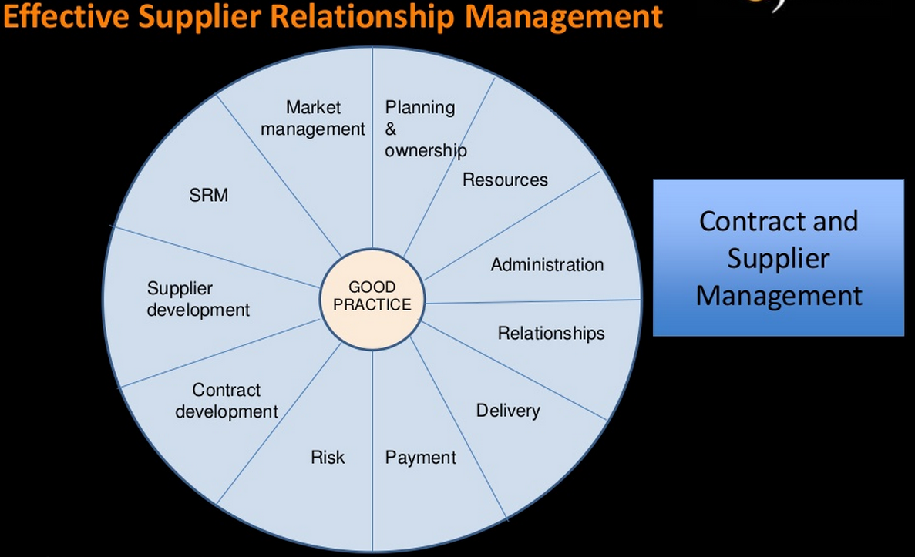

**Major Milestones:**

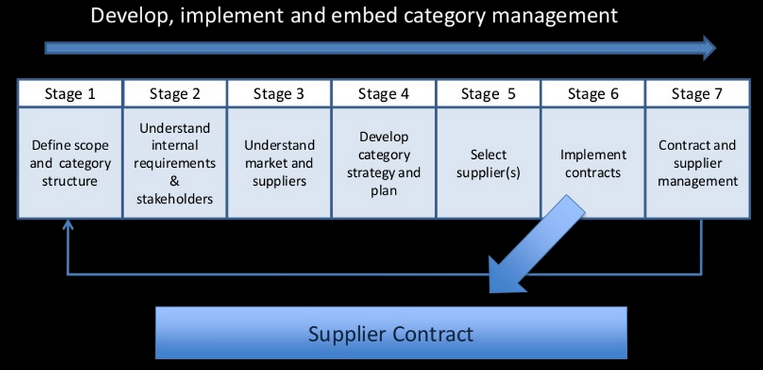

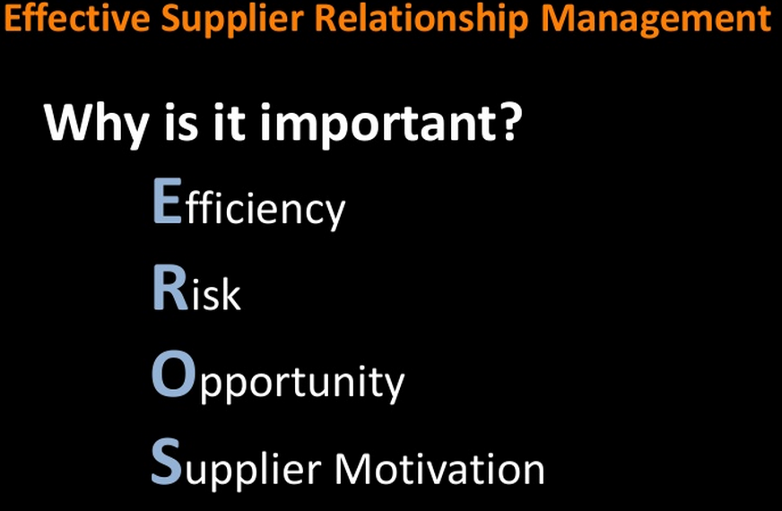

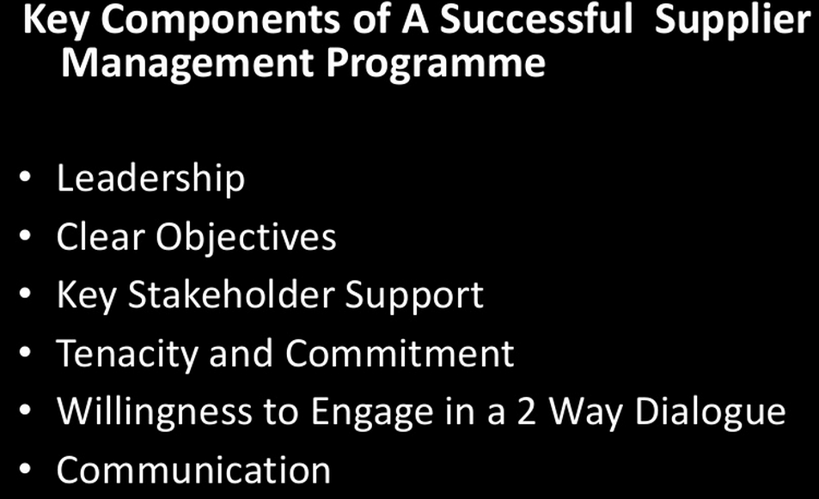

(Note: The Slides above are courtesy of Tejari Consulting Service).

**C: Supplier Performance Measurement**

A Bit of History: 1930-1950

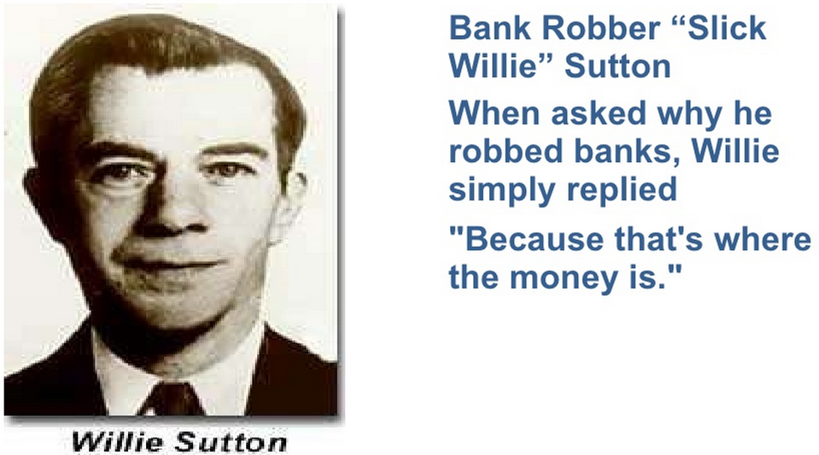

**Supply chain is ‘Where the Money is’:**

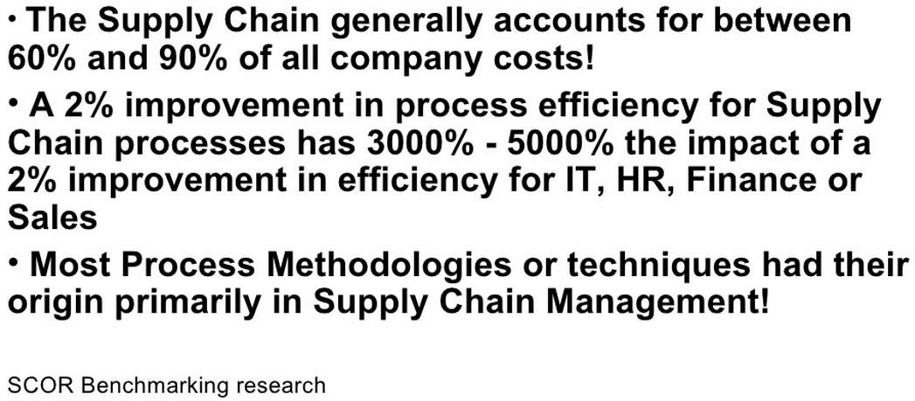

**Some Best-Practices on Supplier Performance Management:**

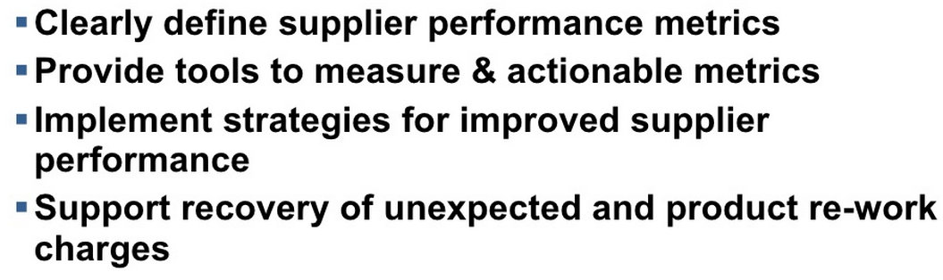

**Life Cycle of Supplier Management:**

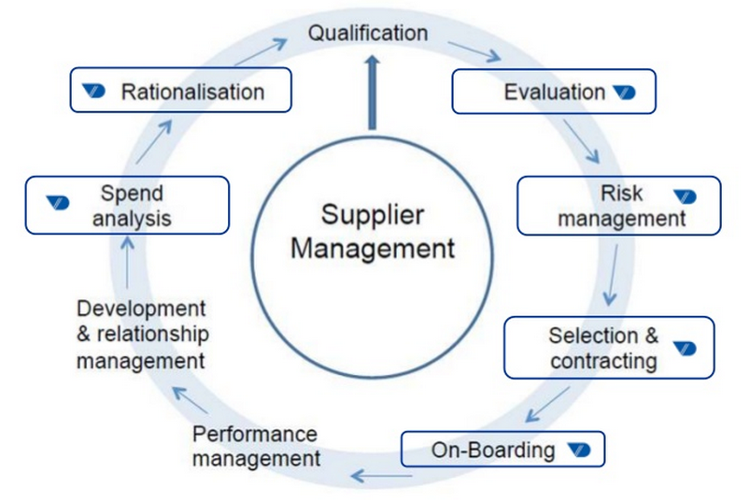

**Some best practice on Supplier Management:**

